|  |  |
| --- | --- |
|  | |
| Summer 2015 | |
|  | |
| Inside this Issue | |
| 1 | Word from the President |
| 2 | Club Spotlight:  Indianapolis |
| 2 | Upcoming Events  From the NSAA Journal |
| 3 | 2015 – 2016 OVSC Board & Officers  Still Wanted |
|  |  |
|  |  |
|  |  |
|  |  |
|  |  |
|  |  |
| **OVSC**  [**www.ovsc.org**](http://www.ovsc.org) | |

The holiday edition



Just finished with Christmas (whew!) and looking forward to the New Year’s celebrations – may you all be safe!

Hoping a healthy 2016 is in store for all of you OVSC’ers.

At the last OVSC Board meeting, we discussed the purpose of the OVSC and what it means to each club within the organization. Deciding that this subject needed some in-depth thought and consideration, we all walked away with “homework” to do. I am eagerly looking forward to the results and feedback each club has to offer. All individual comments are also welcomed, so bring ‘em on!

*What does the OVSC mean to you?

*How does it affect your club?

*How does it affect you?

*What is the purpose of the OVSC?

*How does that relate to you, both as a club and as an individual?

Based on the replies we get, we are going to “perform” the SWOT analysis that Mary Manning and Andrew Kwang presented to the NSCF and the OVSC a few years back.

*What are the **S**trengths, **W**eaknesses, **O**pportunities and **T**hreats?

Following that, we are going to follow that up with the SMART portion: **S**pecific, **M**easureable, **A**chievable, **R**ealistic and **T**ime-sensitive.

Leadership needs to be passionate about their job and focus, and using SWOT will show what we/ you can do and help to understand where we/ you are, help to move away from the threats and weaknesses.

*What is it that you need to do that we/you have not done before?

I challenge each of the clubs to a SWOT/SMART analysis to see what we have in common, what we might be able to do to help each other out, and strengthen our bond.

Don’t’ forget, January is the national “Learn to Ski” month. Ask your local ski hill if they need volunteers, sign up, and don’t forget to advertise your club!!! Make sure you have your club business card, wear club logo sweatshirt or t-shirt, and have fliers with you.

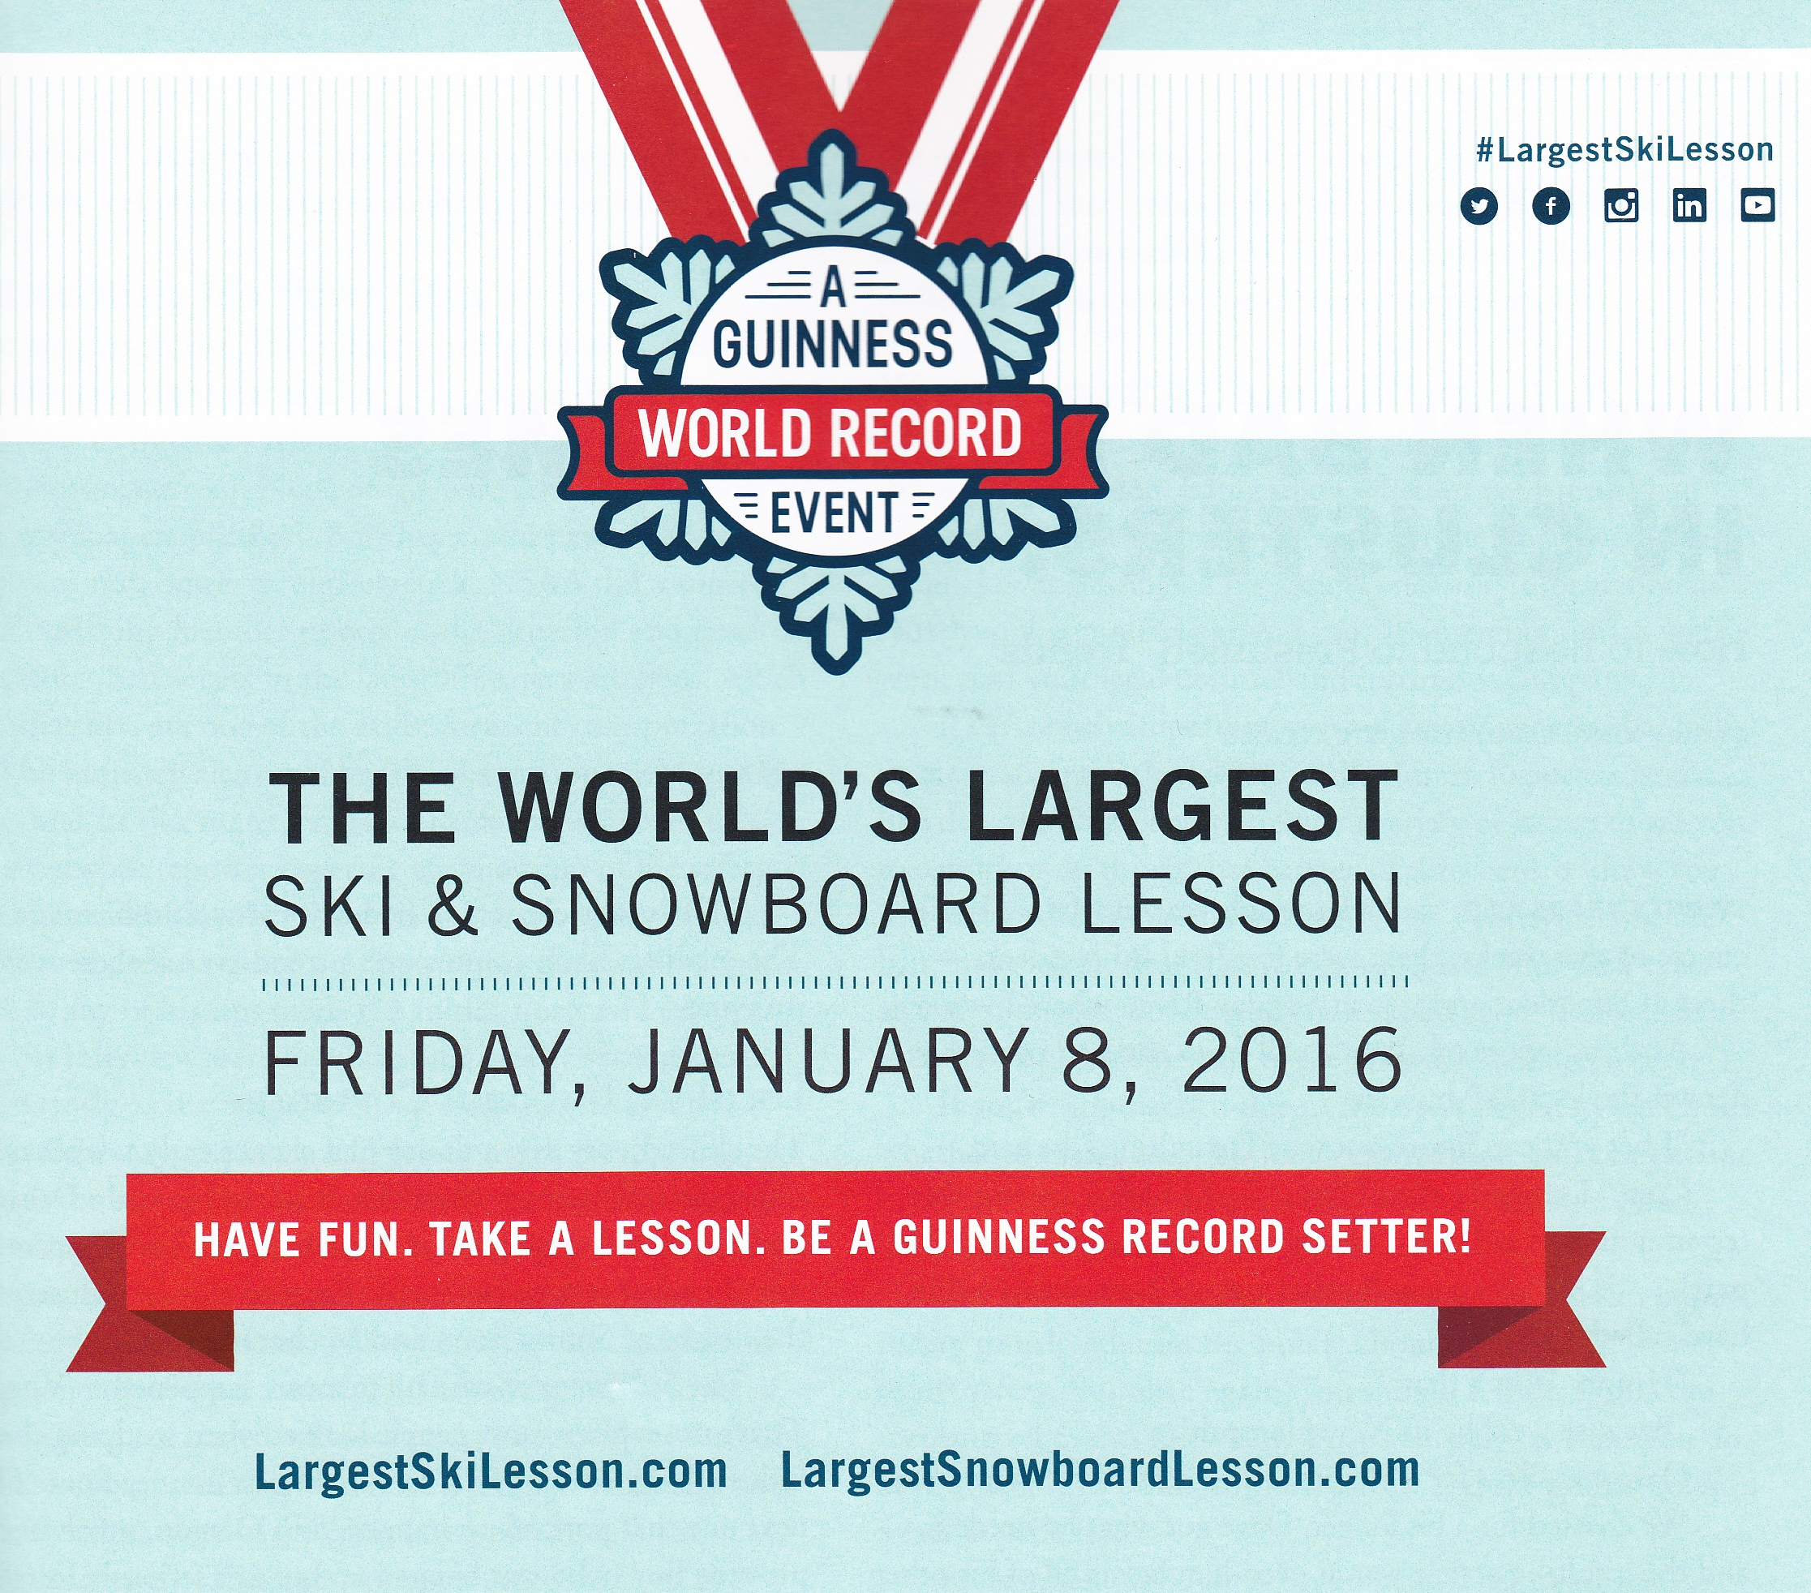

Ski on!

Juli Brace, OVSC President

Spotlight:

Indianapolis

Founded in 1958 by a small group of skiing enthusiasts, the Indy club has evolved over the years, growing to over 1,200 members. The club was a “meet-up” destination in the days before the internet, and at last count boasts over 60 marriages. At one point, the Indy club was the premier racing club in the OVSC. Today, the club has around 250 members, averaging six ski trips a year and monthly social activities. Their ski and snowboarding trips often include lessons provided at no extra charge by their very own PSIA certified instructors.

After the ski season, the club offers weekly bike rides on rail-trails and bike paths around the city. There are several large meetings a year, including a summer BBQ and a Christmas banquet.

Upcoming Events:

**2016**

January 17 - 23

*Whitefish, MT*

For more information, contact Marty Baldwin, [mbaldone@earthlink.net](mailto:mbaldone@earthlink.net)

January 31

OVSC Board & Summit Committee Meeting

For more information, contact Juli Brace, julibrace1@hotmail.com

February 27 – March 6

*Alyeska, AK with Iditarod race start in Anchorage*

For more information, contact Marty Baldwin, [mbaldone@earthlink.net](mailto:mbaldone@earthlink.net)

March 11 - 19

*Solden, Austria, optional London pre-trip & Greek Isles post trip*

For more information, contact Dan Hapner, [rosehapner@aol.com](mailto:rosehapner@aol.com)

April 2 – 10

*Holland River Cruise*

For more information, contact Dan Hapner, [rosehapner@aol.com](mailto:rosehapner@aol.com)

August 8 – 19

*Australia / New Zealand, optional Ayres Rock pre-trip*

For more information, contact Dan Hapner, [rosehapner@aol.com](mailto:rosehapner@aol.com)

The club draws from all over central Indiana, has several members from out-of-state, and enthusiastically supports several charities.

.

From the NSAA (National Ski Areas Association) Journal:

The industry’s benchmark report on participants in downhill snow sports, the *NSAA National Demographic Study*, tracks customer (us skiers and boarders) demographics and trip characteristics. This information shows how the customer base of the sport it evolving.

The 2014-2015 reports presents survey results of more than 135,000 skiers and snowboarders from 89 different ski areas in the United States, and is the 19th consecutive year of the study. The most notable theme to emerge was a continued modest shift to a slightly less experienced and less avid visitor profile, meaning new participants in the sports and a greater level of competition from other activities.

Thevisitor profile age has roughly stabilized over the past 3 season, hovering between 38 and 39 years old, suggesting that younger participants are replacing the older ones who are dropping out of the sport. The number of Baby Boomers has dropped by about a third, as has the older generations as well.

Generation X’ers (35 to 50 in 2015) have trended up, while those Millennials (18 to 34 in 2015) have remained relatively flat over the past 10 years. The strongest growth in recent

seasons is attributable to the post-Millennials (aged 17 and under in 2015), who are increasingly entering the stage as the newest generation to adopt snow sports.

Singles are down, and visitors living in households with children are up, from 31% to 40% of participants.

Those visiting with friends, groups and clubs have also been trending down slightly.

Those of the feminine persuasion – steady growth, gals. Good work!

Minorities are still significantly underrepresented, 11 to 14 % of the overall racial/ethnic mix of ski area visitors. Encouragingly, participation is strongest in the 10 to 35 age range.

Alpine skiers have climbed to 73.1%, while snowboarding has declined to 23.6%. Boarding still continues to have a high percentage of 1st year

participants, so it is attracting younger people, and is a gateway for many

newcomers, with a potential for future growth.

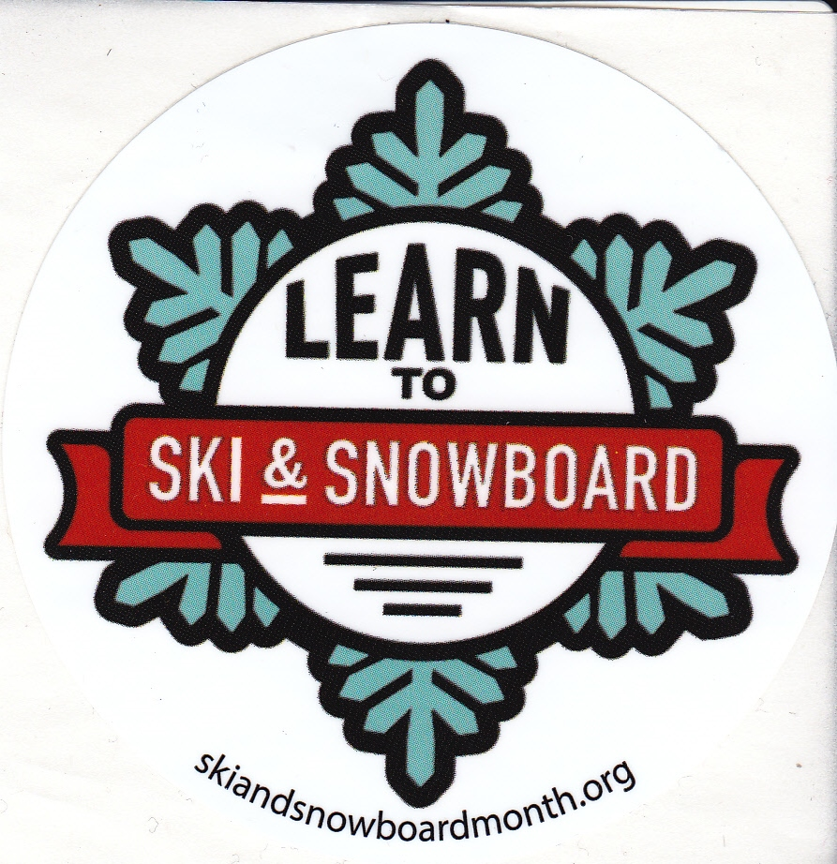

**OVSC BOARD AND TRIP DIRECTORS:**

President: Juli Brace, Cincinnati julibrace1@hotmail.com

Vice President: Janet Jones, Lexington jgjones@email.uky.edu

Secretary: Suzy Berning, Cincinnati suzyberning11@gmail.com

Treasurer: Hew Wells, Kittyhawk hswells@woh.rr.com

International/Summer: Dan Hapner, Dayton rosehapner@aol.com

North America: Marty Baldwin, Dayton [mbaldone@earthlink.net](mailto:mbaldone@earthlink.net)

Bob LeValley, Dayton rdlevalley@gmail.com

Racing: Rick Mygrant, Cincinnati OVSCrick@cinci.rr.com



Still Wanted:

News and events from your club to be “published” in the OVSC Newsletter.

Excerpts from your newsletter that you want the other 16 OVSC clubs to know about: ski trips, events and outings, club anniversaries.

Photos from your trips and outings, with names, places, dates, etc.

Let me know, please.

Juli Brace

OVSC President

julibrace1@hotmail.com

