**C:\Documents and Settings\nancy\Local Settings\Temporary Internet Files\Content.IE5\J35N0PF7\MC900001521[1].wmfC:\Documents and Settings\nancy\Local Settings\Temporary Internet Files\Content.IE5\0E0THQGK\MC900390698[1].wmfSki Trip**

**St. Ambrose Life Teen & Edge  
Monday – January 2, 2012  
Wisp Resort**

**Cost:** $40 per person plus money for lunch/dinner

Includes: Lift Ticket, Rentals, 60 minute clinic, Transportation - two 15 person vans

Cost without transportation $29 plus money for lunch/dinner

**Signup & Payment Due December 26!** Make checks payable to: St. Ambrose   
Turn in to Robin or John Ambrozy at any LifeTeen night, or Nancy Miller.

Friends Welcome! Transportation is available, but limited seating – so sign up now!

All students will be grouped with an experienced skiier/snowboarder. Adults - If you are a current skiier/snowboarder and can help guide, please email [NancyMillersEmail@gmail.com](mailto:NancyMillersEmail@gmail.com) or call Nancy Miller at 740-525-8124. We will also have a few volunteers from the Ohio Valley Ski Club!

Wisp Resort is in Deep Creek Lake, Maryland and is an easy 2 ½ - 3 hour drive. The $29 special is their 2012 “Monday Specials”. Otherwise, the group rate on a crowded Sunday is at least $80. Warren & Belpre schools are still out on January 2nd ! Lucky us! This rate of $29 is available to everyone, it’s not a group rate. You can check it out at [www.wispresort.com](http://www.wispresort.com)

We’ll also have a meeting for everyone who signs up on December 26th from 7 – 8:30 pm at St. Ambrose. We’ll make sure everyone knows what type of snow gear to bring and give some basic tips on putting on skis and snowboards.

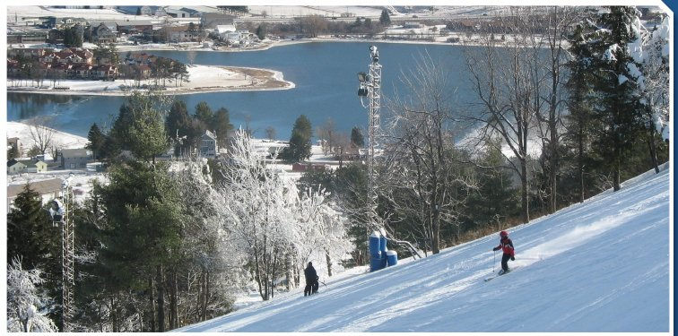

**What to bring:**

(ski) Jacket

Snow pants

Gloves (waterproof)

Helmet (optional)

Hat/Scarf

Money for food

**Ski Trip Sign Up Form**

Name_____________________________________

Email:_____________________________________

Phone:____________________________________

Age:__________________________

Address:______________________________________________________________________

Circle choice: SKI / SNOWBOARD

Do you need to rent equipment: Yes / No

<https://mail.google.com/mail/u/0/?ui=2&ik=65694e7843&view=att&th=13425c307d894221&attid=0.1&disp=safe&realattid=f_gvzzw6wj0&zw>

Shoe size:______________

My child is permitted to travel to Wisp resort with the St. Ambrose Life Teen Group.

Parents Name:_________________________________________

Parents Signature:______________________________________

Parents Phone Number(s)________________________________________________________________